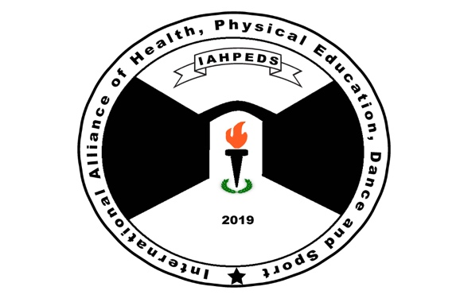

IAHPEDS World Congress Tokyo 2024

Congress Hotel: Hotel Mets Kokubunji Reservation

Rooms reserved for the nights of July 4, 5, 6, and 7, 2024, are at the discount/negotiated rate. Dates before and after are not available on the hotel website but are available on travel websites such as Expedia.com – so book those nights on your own and soon! Make sure your name is the same on both bookings for the same type of room (non-smoking and single, double or twin) and make sure it is Hotel Mets Kokubunji.

All payments will be in Japanese Yen when checking out, so conversion to $US will be based on the exchange rate at that time. One night including taxes and breakfast the next morning:
Single: 55” bed width – 10,200 Yen –Equivalent of $68 at current exchange rate of 150 Yen to 1 USD. The hotel charges more for Saturday nights so July 6 will be 12,700 Yen- $85.
Double, 2 people: 63” bed width – 16,600 Yen - $111 and July 6 will be 18,600 Yen - $124
Twin: 2 beds with 47” and 39” bed widths – NO LONGER AVAILABLE

* These prices are subject to change. We will inform you if prices do change.

Your Name:

Today’s Date:

Room Type Requested (Single, or Double with one bed)

Dates of Nights Requested:

(If you will check in on July 4 and leave on 8, then you would put July 4, 5, 6, 7 nights.)

Your email:

Send this completed form to: steven.wright@unh.edu AND iahpeds.2024.japan@gmail.com.

